16.7: Use 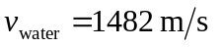at 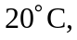 as given in Table 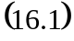 The sound wave travels in water for the same time as the wave travels a distance 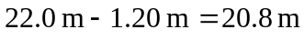 in air, and so the depth of the diver is

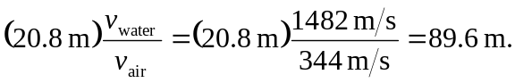

This is the depth of the diver; the distance from the horn is 

